Machine industrielle didactisée
_____________________________________________________

_____________________________________________________

_____________________________________________________

_____________________________________________________



DECMA-PARK
BARRIERE DE PARKING

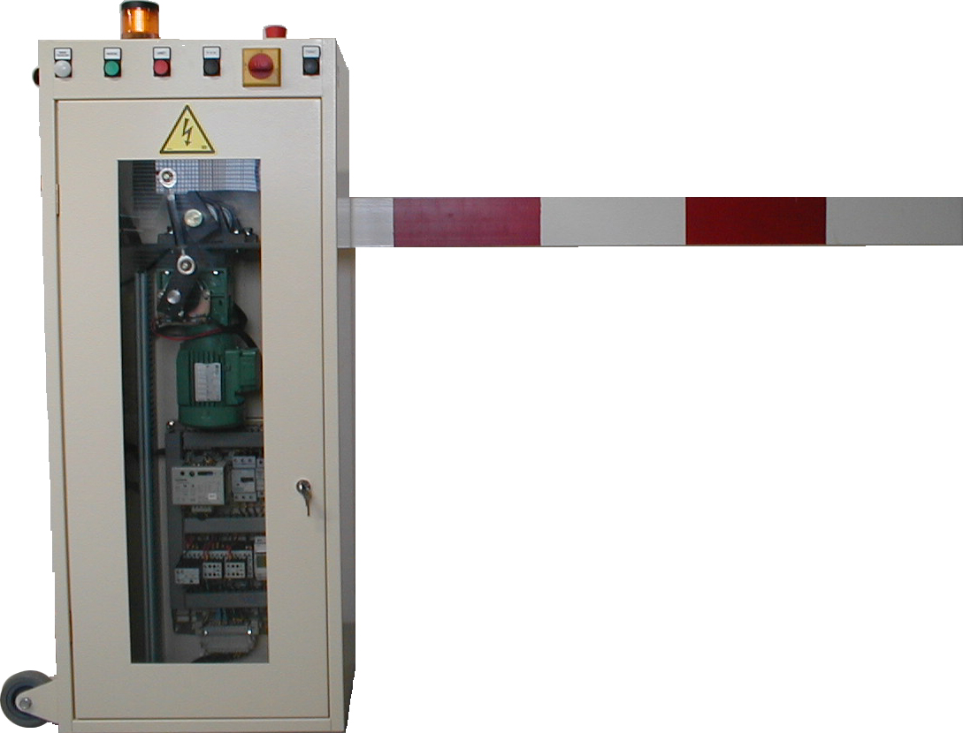

Version PO – 380V~

Manuel technique

